

**Bachelor of Information Technology (Hons)**

**Assignment Cover Sheet**

CourseCodeEC3105 Course Title:C-Programming

AssignmentTitle: Assignment 2 Due Date:May 26

Date Submitted: May 26 Lecturer Name: Aashish Acharya

**To be completed if this is an individual assignment**

I declare that this assignment is my individual work. I have not worked collaboratively nor have I copied from any other student’s work or from any other source except where due acknowledgement is made explicitly in the text, nor has any part been written for me by another person.

StudentName:Kishor Chaudhary Student ID:________________ Signature:kishor

**To be completed if this is a group assignment**

We declare that this is a group assignment and that no part of this submission has been copied from any other student's work or from any other source except where due acknowledgement is made explicitly in the text, nor has any part been written for us by another person.

Student ID Student Name Signature

_________ __ ______________________________________ __________

_________ __ ______________________________________ __________

_________ __ ______________________________________ ____ ______

_________ __ ______________________________________ __________

Lecturer's comments: _______________________________________________________

_________________________________________________________________________

Total Marks: ______________ Lecturer's Signature:_________________

**Feedback to Student:**

I/We acknowledged receiving feedback from the lecturer on this assignment.

Student’s Signature: ____________ _____________ _____________ ___________

**Extension certification:**

This assignment has been given an extension and is now due on _______________.

Lecturer’s Signature: _____________

Contents

Algorithm 4

Flowchart 7

Source Code 16

Output 20

Documentaions 22

Marking Scheme 23

Write a program to read the IDs and their final exam total of 10 students and perform the following operations on data:

* Show the top three scorers of the batch.
* Sort the data on descending order of total marks.
* Calculate the average marks of the batch.
* Find all students scoring above 70% (full marks is 500) and print them.

Please keep note of the following details while building the solution:

1. You are not allowed to make use of Global Variables, use local variables and pass them as parameters/values/references if you need to use them across functions.
2. Your system should show choices after user inputs two matrices, choices to to perform each of the following operations.
3. Your program should continuously run until user prompts to quit. Input and result of each calculation should be stored in a file. You are required to a create file record for each session. It is not mandatory to keep records of old sessions.

# Algorithm

Step1:Start

Step2:Declare the following variables with the following purposes:

Id:to store student id

S0:to store marks of student id1

S1:to store marks of student id 2

S2: to store marks of student id1

S3 :to store marks of student id4

S4:to store marks of student id5

S5:to store marks of student id6

S6:to store marks of student id7

S7: to store marks of student id8

S8 :to store marks of student id9

S9:to store marks of student id10

Sum:to store sum of marks of students

Num:to store number from user

Num1:to store temporary number

Total:to store sum of marks of all students

First:to store 1st scorer

Second :to store 2nd scorer

Third:to store 3rd scorer

Average:to store average marks of the batch

Step 3:Repeat the following process until the i value is <10 otherwise go to step4

i=0

Read the ids of students

i++

goto step 3

step4: Repeat the following process until the i value is <5 otherwise go to step5

i=0

Read the marks student1

i++

goto step 4

Step5: Repeat the following process until the i value is <5 otherwise go to step6

i=0

Read the marks of student2

i++

goto step 5

step6:Repeat the following process until the i value is <5 otherwise go to step7

i=0

Read the marks of student3

i++

goto step 6

Step7:Repeat the following process until the i value is <5 otherwise go to step8

i=0

Read the marks of student4

i++

goto step 7

Step8:Repeat the following process until the i value is <5 otherwise go to step9

i=0

Read the marks of student5

i++

goto step 8

Step9:Repeat the following process until the i value is <5 otherwise go to step10

i=0

Read the marks of student6

i++

goto step 9

Step10:Repeat the following process until the i value is <5 otherwise go to step11

i=0

Read the marks of student7

i++

goto step 10

Step11:Repeat the following process until the i value is <5 otherwise go to step12

i=0

Read the marks of student8

i++

goto step 11

Step12:Repeat the following process until the i value is <5 otherwise go to step13

i=0

Read the marks of student9

i++

goto step 12

Step13:Repeat the following process until the i value is <5 otherwise go to step14

i=0

Read the marks of student10

i++

goto step 13

Step14:sum[0]=s0[0]+s0[1]+s0[2]+s0[3]+s0[4]

sum[1]=s1[0]+s1[1]+s1[2]+s1[3]+s1[4]

sum[2]=s2[0]+s2[1]+s2[2]+s2[3]+s2[4]

sum[3]=s3[0]+s3[1]+s3[2]+s3[3]+s3[4]

sum[4]=s4[0]+s4[1]+s4[2]+s4[3]+s4[4]

sum[5]=s5[0]+s5[1]+s5[2]+s5[3]+s5[4]

sum[6]=s6[0]+s6[1]+s6[2]+s6[3]+s6[4]

sum[7]=s7[0]+s7[1]+s7[2]+s7[3]+s7[4]

sum[8]=s8[0]+s8[1]+s8[2]+s8[3]+s8[4]

sum[9]=s9[0]+s9[1]+s9[2]+s9[3]+s9[4]

Step15:Repeat the folllowing process until the value is 5 other wise go to step

print"What operation do you need to do of the data enter the number accordingly as mentioned below”

print"To find top three scorers of the batch enter 1.”

print"To sort the data on descending order of total marks enter 2”

print"To find the average marks of the batch enter 3.”

print"To find all students scoring above 70 percent enter 4”

print"Enter 5 to quit”

Step16:Read a number and store it in num.

Step17:if (num==1)

Repeat the following process until the value becomes 10 otherwise go to step15

i=0

if (sum[i]>first) then

third=second

second=first

first=sum[i]

print”the first highest number “

else if(sum[i]>second)

second=sum[i]

print”the second highest number”

else(sum[i]>third)

third=sum[i]

print”the third highest number”

i++

go to step17

Step18:else if (num==2)

Repeat the following process until i becomes 10 otherwise go to step21

i=10

Step19 :Repeat the following process until j becomes 10 otherwise go to step20

j=i+1

if (sum[i]<sum[j])

num1=sum[i]

sum[i]=sum[j]

sum[j]=num1

j++

go to step19

Step20 :i++

go to step18

Step21:Repeat the following process until the value become10 otherswise go to step15

i=0

print the marks in decending order

i++

go to step21

step22:else if (num==3)

total=sum[0]+sum[1]+sum[2]+sum[3]+sum[4]+sum[5]+sum[6]+sum[7]+

sum[8]+sum[9]

Average=total/10;

Step23:print “The average marks obtaied by the batch”

Step24:go to step15

Step25:else if (num==4)

Step 26:Repeat the following process until the I become 9 otherwise go to step15

I=0

If (sum[i]>350)

Print”the id with the marks”

i++

go to step26

Step27:else if

Print”Invalid input”

Go to step 15

Step28:else (num==5)

Step30:Got to step 31

Step31:Stop

# Flowchart

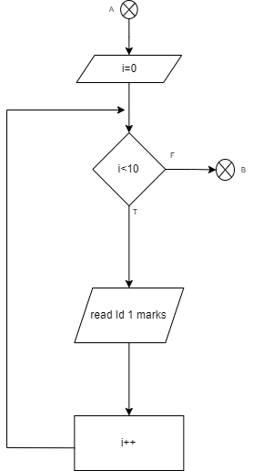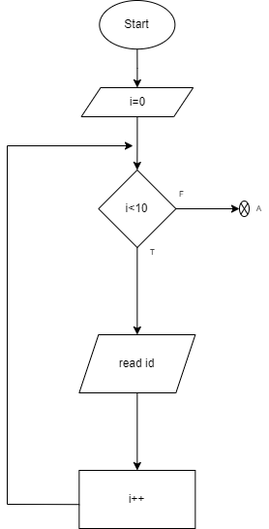

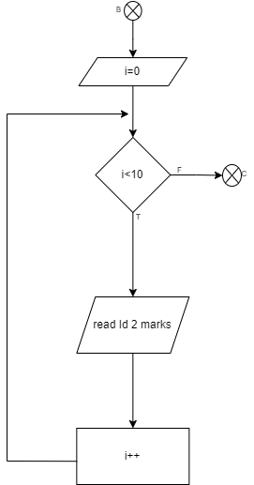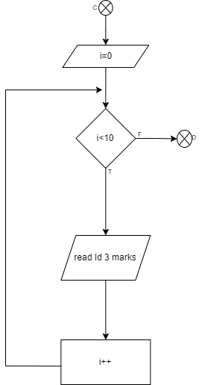

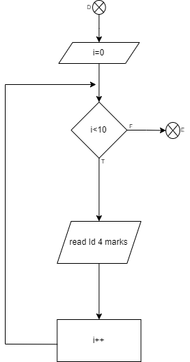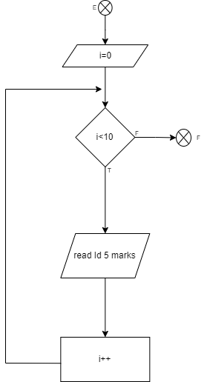

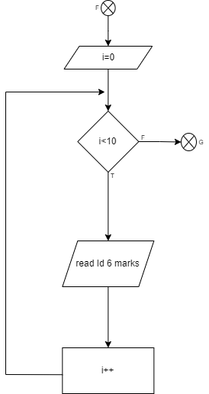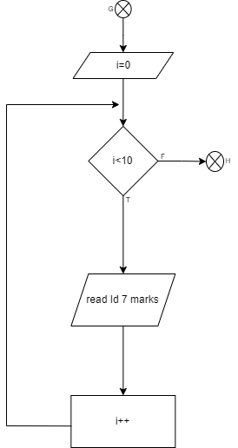

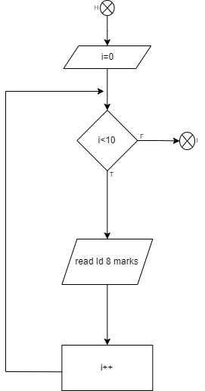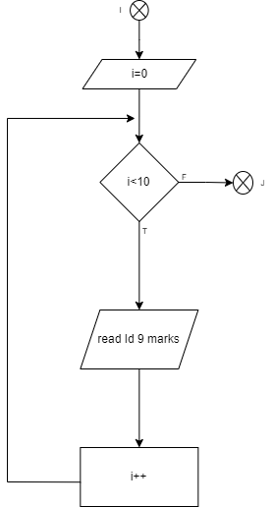

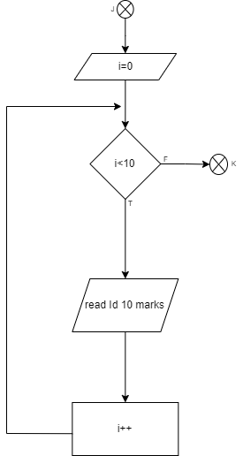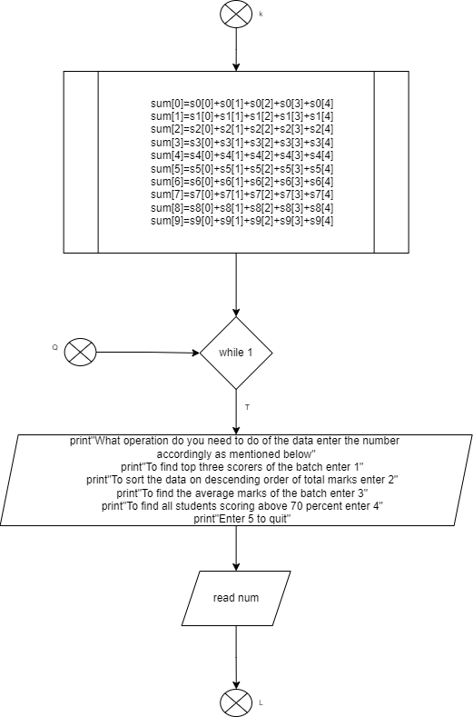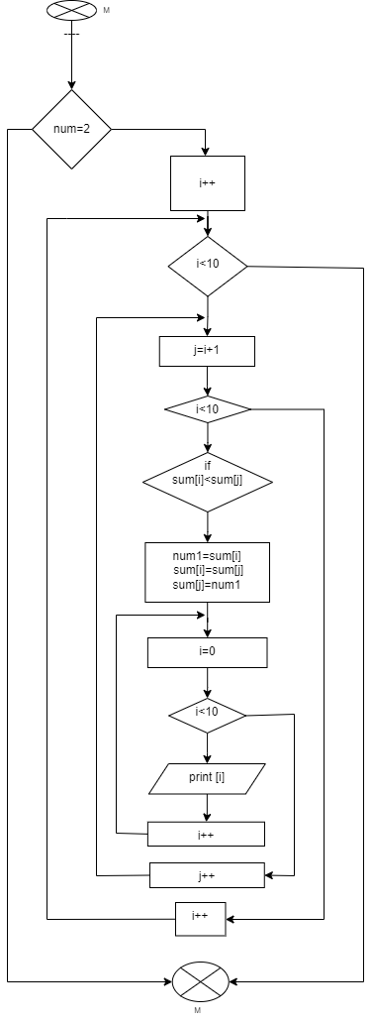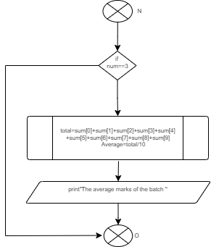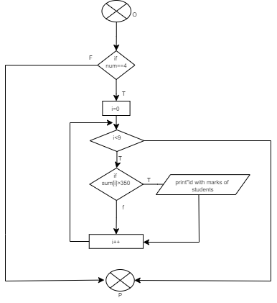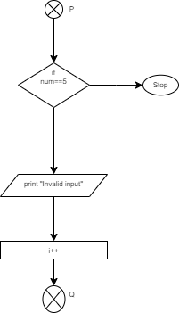

# Source Code

#include <stdio.h>

int FinalMark();

int main()

{

FinalMark();

printf("\n");

}

int FinalMark()

{

int Id[10],i,s0[5],s1[5],s2[5],s3[5],s4[5],s5[5],s6[5],s7[5],s8[5],s9[5];

for(i=0;i<10;i++)

{

printf("Enter the student ID %d: ",i+1);

scanf("%d",&Id[i]);

}

printf("\n");

printf("Enter the marks of every subject of student with ID %d:\n",Id[0]);

for(i=0;i<5;i++)

{

scanf("%d",&s0[i]);

}

printf("Enter the marks of every subject of student with ID %d:\n",Id[1]);

for(i=0;i<5;i++)

{

scanf("%d",&s1[i]);

}

printf("Enter the marks of every subject of student with ID %d:\n",Id[2]);

for(i=0;i<5;i++)

{

scanf("%d",&s2[i]);

}

printf("Enter the marks of every subject of student with ID %d:\n",Id[3]);

for(i=0;i<5;i++)

{

scanf("%d",&s3[i]);

}

}

printf("Enter the marks of every subject of student with ID %d:\n",Id[4]);

for(i=0;i<5;i++)

{

scanf("%d",&s4[i]);

}

printf("Enter the marks of every subject of student with ID %d:\n",Id[5]);

for(i=0;i<5;i++)

{

scanf("%d",&s5[i]);

}

printf("Enter the marks of every subject of student with ID %d:\n",Id[6]);

for(i=0;i<5;i++)

{

scanf("%d",&s6[i]);

}

printf("Enter the marks of every subject of student with ID %d:\n",Id[7]);

for(i=0;i<5;i++)

{

scanf("%d",&s7[i]);

}

printf("Enter the marks of every subject of student with ID %d:\n",Id[8]);

for(i=0;i<5;i++)

{

scanf("%d",&s8[i]);

}

printf("Enter the marks of every subject of student with ID %d:\n",Id[9]);

for(i=0;i<5;i++)

{

scanf("%d",&s9[i]);

}

int num,sum[10],num1,total=0,first=0,second=0,third=0;

sum[0]=s0[0]+s0[1]+s0[2]+s0[3]+s0[4];

sum[1]=s1[0]+s1[1]+s1[2]+s1[3]+s1[4];

sum[2]=s2[0]+s2[1]+s2[2]+s2[3]+s2[4];

sum[3]=s3[0]+s3[1]+s3[2]+s3[3]+s3[4];

sum[4]=s4[0]+s4[1]+s4[2]+s4[3]+s4[4];

sum[5]=s5[0]+s5[1]+s5[2]+s5[3]+s5[4];

sum[6]=s6[0]+s6[1]+s6[2]+s6[3]+s6[4];

sum[7]=s7[0]+s7[1]+s7[2]+s7[3]+s7[4];

sum[8]=s8[0]+s8[1]+s8[2]+s8[3]+s8[4];

sum[9]=s9[0]+s9[1]+s9[2]+s9[3]+s9[4];

while(1)

{

printf("What operation do you need to do of the data enter the number accordingly as mentioned below:\n");

printf("To find top three scorers of the batch enter 1.\n");

printf("To sort the data on descending order of total marks enter 2.\n");

printf("To find the average marks of the batch enter 3.\n");

printf("To find all students scoring above 70 percent enter 4.\n");

printf("Enter 5 to quit\n");

scanf("%d",&num);

if (num==1)

{

for(int i=0;i<10;i++)

{

if(sum[i]>first)

{

third=second;

second=first;

first=sum[i];

}

else if(sum[i]>second)

{

second=sum[i];

}

else if(sum[i]>third)

{

third=sum[i];

}

}

printf("first highest marks of student of id %d is %d \n",Id[i],first);

printf("second highest marks of student of id %d is %d \n",Id[i],second);

printf("third highest marks of student of id %d is %d \n",Id[i],third);

}

else if (num==2)

{

for(i=0;i<10;i++)

{

for(int j=i+1;j<10;j++)

{

if(sum[i]<sum[j])

{

num1=sum[i];

sum[i]=sum[j];

sum[j]=num1;

}

}

}

printf("The sorted the data on descending order of total marks are:\n" );

for (i=0;i<10;i++)

{

printf("%d ",sum[i]);

}

}

else if (num==3)

{

total=sum[0]+sum[1]+sum[2]+sum[3]+sum[4]+sum[5]+sum[6]+sum[7]+sum[8]+sum[9];

float Average=(float)total/10;

printf("The average marks of the batch is %f\n",Average);

}

else if (num==4)

{

printf("Students scoring above 70 percent are:\n");

for(i=0;i<9;i++)

{

if (sum[i]>350)

printf("Id %d with total marks %d\n",Id[i],sum[i]);

}

}

else if (num==5)

{

break;

}

else

{

printf("Invalid Input\n");

}

printf("\n");

i++;

}

printf("\n");

return 0 ;

}

# Output

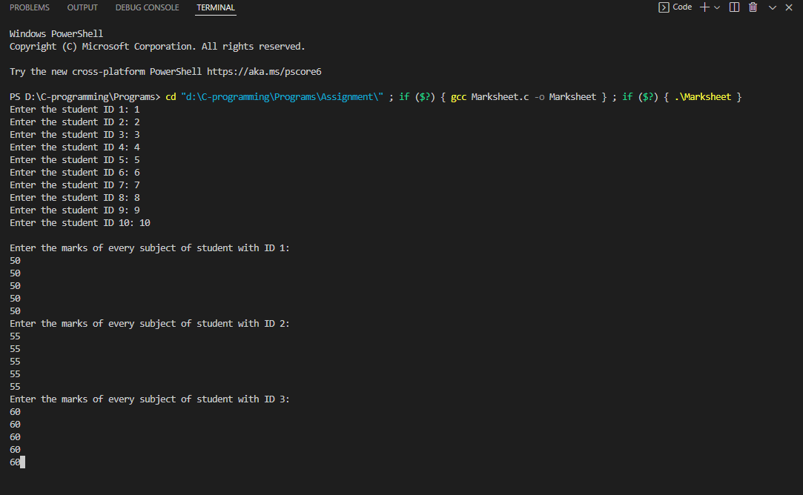

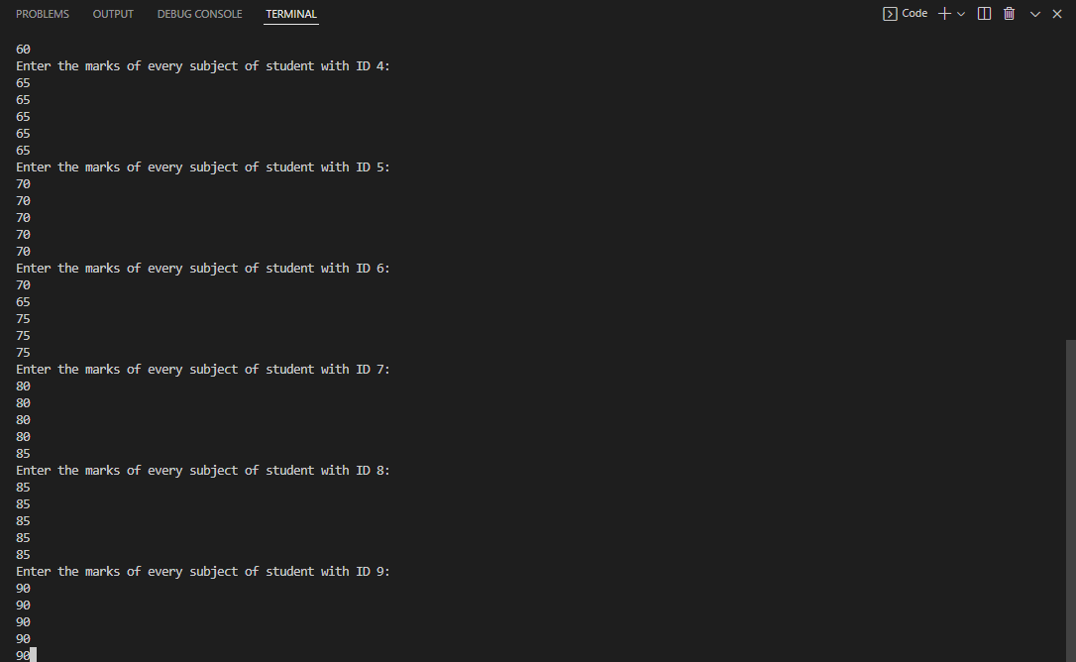

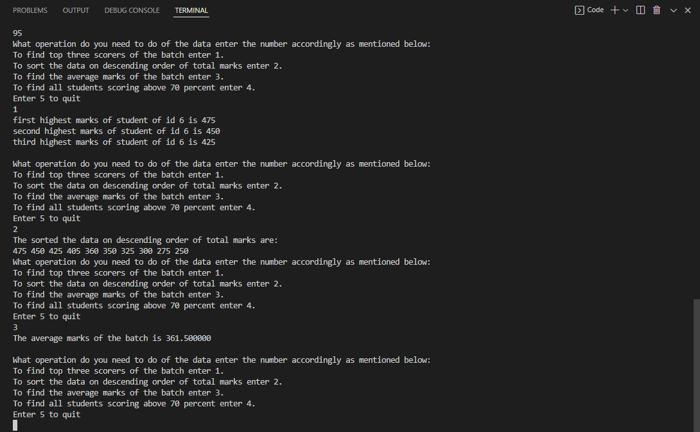

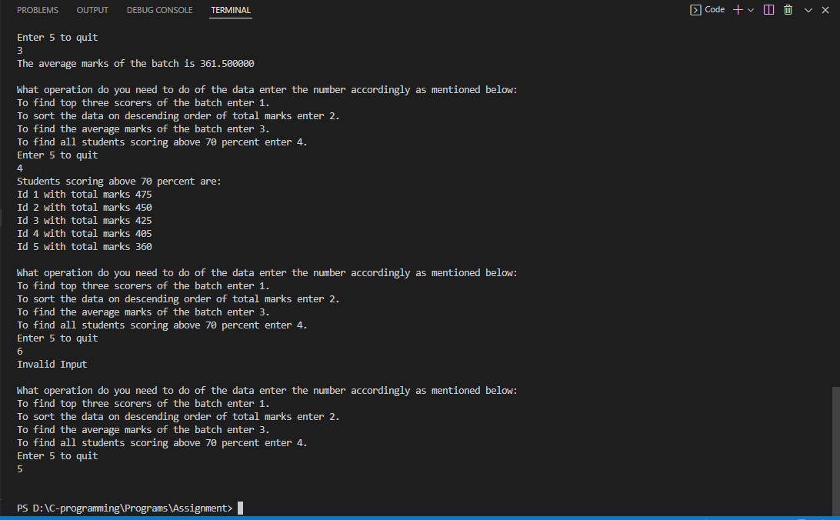

# Documentaions

This the c-program to read id of 10 studens and marks of each 5 subject and with the help of array.User is able to quit the program whenever he/she wants and by user input the program show the different output.eg. Top three higher marks obtaied student,arranging the marks in decending order,average of batch,and students who have got 70% above marks.Hence the program is executed successfully and outputed is shown.

# Marking Scheme

Course: EC3105 (C Programming)

Lecturer: Aashish Acharya

Student name:Kishor

|  |  |  |
| --- | --- | --- |
|  | Full Marks | Obtained Marks |
| Cover Page/Table of Contents |  |  |
| Algorithm | 15 Marks |  |
| Flowchart | 10 Marks |  |
| Documentation | 5 Marks |  |
| Code |  |  |
| Proper Variables and input | 7 Marks |  |
| Usage of Functions and Files | 24 Marks |  |
| Correctness Outcome | 24 Marks |  |
| Demo |  |  |
| Complete Demo | 10 Marks |  |
| Viva Answers | 5 Marks |  |
| Total | 100 Marks |  |